

IDIWA PARENTS’ SECONDARY SCHOOL

SENIOR THREE END OF YEAR EXAMINATION-2023

MATHE MATIC

PAPER 1

Duration 2.5 hours

**INSTRUCTIONS**

* *This paper consists of two sections A and B.*
* *Section A has 10 question compulsory questions and answer any two from section B*
* *Use a graph paper for graph work.*

Section A.

1. A circular flower garden has a radius of 21m. The owner wants to put a plastic edge around the garden. How long should this plastic edge be? (04 marks)
2. The ratio of the cost of milk to the cost of soft drink is 6:10. If a litre of milk costs sh. 3300, what does a litre of soft drink cost? (04 marks)
3. Jonathan is three times as old as Suzan, but the sum of their age is not more than 32 years. What is their greatest possible ages? (04 marks)
4. A ruler 30m long is broken into two pieces, one of the pieces is x cm long and the other piece is (x-4) cm long. What is the value of x? (04 marks)
5. A family spends shs. 7200 a week on sugar. The price of sugar goes up in the ratio 5:4, but at the same time the family reduces their consumption in the ratio 5:6. How much will the family spend on sugar in a week in future? (04 marks)
6. A tree is midway between points E and F 14m apart. A is a point on top of the tree 7m above the ground. How far is F from the top of the tree? (04 marks)

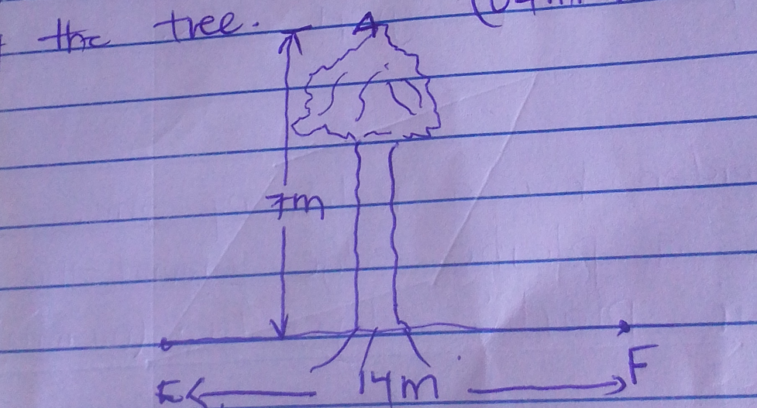

1. 40 learners were asked what they know about Obama Barack and their responses were recorded. 11 responded that he was a basket player (B), 29 said that he was Politician (P) and 5 did not know anything about him. Represent the information on a Vern diagram and find the number of leaners who said he was both a player and a politician. (04 marks)
2. The line joining P (8, 7) and Q (7, -6) is perpendicular to the line containing R (2, 4) and T(x, 3). Find the value of x. (04 marks)
3. Joseph drew a line on a Cartesian plane. The line started from point A(2, 2) and ended at point B(9, 8). What is the length of the line that joseph drew? (04 marks)
4. Joseph bought a trouser on 03/10/2023 at shs. 30,000, when he went back after 3 weeks, he found when the price was increased by 18%. How much did joseph pay for the trouser? (04 marks)

SECTION B

1. a) In the first few days of its life, the length of an earthworm is believed to be proportional to the square root of the number of hours which have passed by since birth.
2. If a warm is 4cm long after 4 hours, determine how long it will be after 6 hours. (04 marks)
3. How long will it take to grow to a length of 14cm? (02 marks)

b) Jamal is an engineer on construction. When he wanted to construct his house, he used a scale of 1cm: 3m. He wanted a bedroom of 5m: 4m of length and width respectively. What were the dimensions of his bedroom on a map? (04 marks)

c) The data below gives the marks of students in English and History.

|  |  |  |  |  |  |  |  |  |  |  |
| --- | --- | --- | --- | --- | --- | --- | --- | --- | --- | --- |
| English | 16 | 36 | 35 | 22 | 24 | 34 | 22 | 43 | 40 | 26 |
| History | 6 | 28 | 36 | 18 | 28 | 37 | 9 | 42 | 15 | 16 |

1. Plot a graph of the marks of the two subjects and draw a line of best fit (06 marks)
2. Describe the correlation of the two subjects and estimate the English marks of a learner who scored 40 in history, (02 marks)
3. 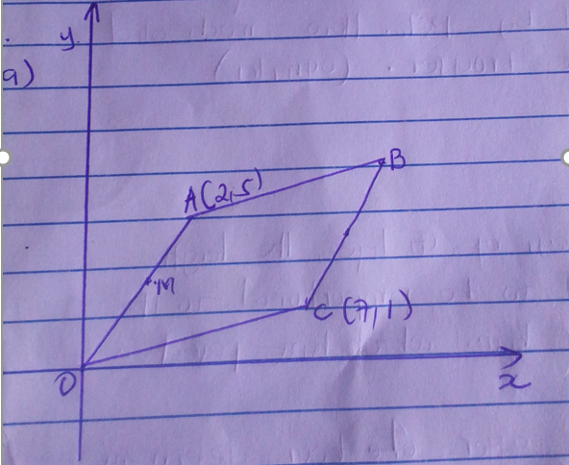
4. Work out the coordinates of B (04 marks)
5. Workout the coordinates of the midpoint M and N of OA and BC respectively. (05 marks)
6. Show that OMBN is a parallelogram. (06 marks)

b) Given the points P(1, 5), Q(0, 3) and R(-3, -3). Do this points lie on a straight line? Show your working. (05 marks)

1. a) Josephine at the top of building 24m high observes a small car approaching the building directly below her position.

At first the angle of depression is 120 and later 400. How far did the car advanced between first and second observation? (10 marks)

b) The angle of elevation of a bird up from a point on the ground is 400. If the bird is 200m above the ground, what is the distance from the point on the ground to the bird? Sketch the diagram. (05 marks)

c) From the top of the building 7.6m above the horizontal ground, the angle of depression of a stone lying on the ground is 580. Calculate the distance of the stone from the foot of the wall. (05 marks)

1. The height of different learners in a certain school are given below.

|  |  |  |  |  |  |  |  |  |
| --- | --- | --- | --- | --- | --- | --- | --- | --- |
| Height (cm) | 41-50 | 51-60 | 61-70 | 71-80 | 81-90 | 91-100 | 101-110 | 111-120 |
| Frequency |  |  |  |  |  |  |  |  |

1. Draw a cumulative table. (07 marks)
2. Plot a cumulative curve and estimate the median height. (08 marks)
3. Workout the mean height. (06 marks)

**END**

Merry Christmas & Happy New Year